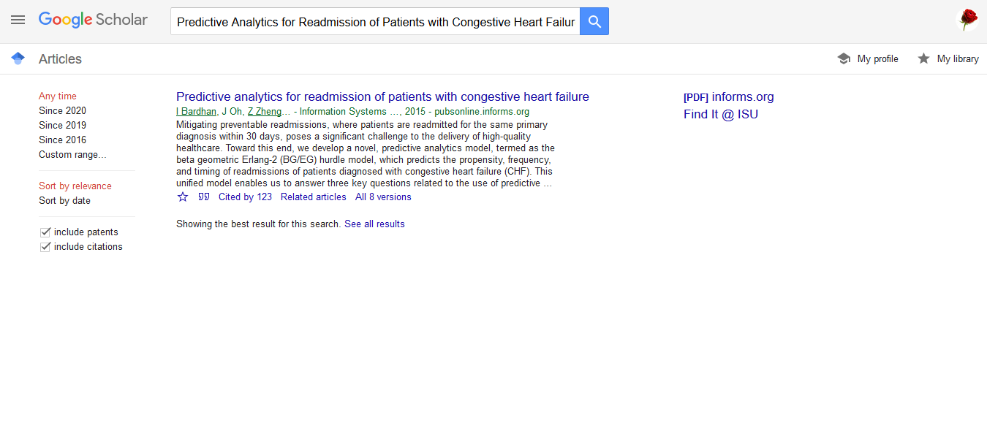

**The APA citation**

Bardhan, I., Oh, J. H., Zheng, Z., & Kirksey, K. (2015). Predictive analytics for readmission of patients with congestive heart failure. *Information Systems Research*, *26*(1), 19-39.